**PRACTICAL-4**

**AIM: Write a C program to stimulate lexical analyser for validating operator.**

**CODE:**

#include<stdio.h>

#include<conio.h>

#include<string.h>

int main()

{

int l,i,n,t,h;

char a[30];

printf("Enter any string:");

gets(a);

l = strlen(a);

n=l;

for(i=0;i<l;i++)

{

if(a[i]=='&')

{

if((a[i]=='&' && a[i+1]=='&')&& i+1<n)

{

printf("&& : Logical AND operator\n"); i++;

}

else

{

printf("%c : Bitwise AND operator\n",a[i]);

}

}

if(a[i]=='|')

{

if((a[i]=='|' && a[i+1]=='|')&& i+1<n)

{

printf("|| : Logical OR operator\n"); i++;

}

else

{

printf("%c : Bitwise OR operator\n",a[i]);

}

}

if(a[i]=='^')

{

if((a[i]=='^' && a[i+1]=='=')&& i+1<n)

{

printf("^= : Assignment operator\n"); i++;

}

else

{

printf("%c : Bitwise EX-OR operator\n",a[i]);

}

}

if(a[i]=='+')

{

if((a[i]=='+')&& (a[i+1]=='+'))

{

printf("++ : Increment operator\n");i++;

}

else

{

printf("+ : Addition\n"); }

}

if(a[i]=='-')

{

if((a[i]=='-')&& (a[i+1]=='-'))

{

printf("-- : Decrement operator\n");i++;

}

else

{

printf("- : Subtraction\n");

}

}

if(a[i]=='*')

{

printf("* : Multiplication\n");

}

if(a[i]=='/')

{

printf("/ : Division\n");

}

if(a[i]=='%')

{

printf("% : Modulo\n");

}

if(a[i]=='>')

{

if((a[i]=='>')&&(a[i+1]=='='))

{printf(">= : Greater Than or Equal to\n"); i++;}

else if((a[i]=='>')&&(a[i+1]=='>'))

{

printf(">> : Right Shift\n");i++;

}

else

{

printf("> : Greater Than\n");

}

}

if(a[i]=='<')

{

if((a[i]=='<')&&(a[i+1]=='=')&&i+1<n)

{

printf("<= : Less Than or Equal to\n");i++;

}

else if((a[i]=='<')&&(a[i+1]=='<')&&i+1<n)

{

printf("<< : Left Shift\n");i++;

}

else

{

printf("< : Less Than\n");

}

}

if(a[i]=='=')

{

if((a[i]=='=') && a[i+1]=='=')

{

printf("== : Equal To\n");i++;

}

else

{

printf("= : Assignment\n"); } } }

return 0;

}

**OUTPUT:**

**TEST CASE - 1:**

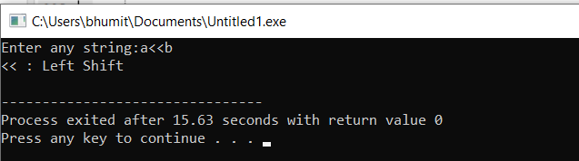

**TEST CASE -2:**

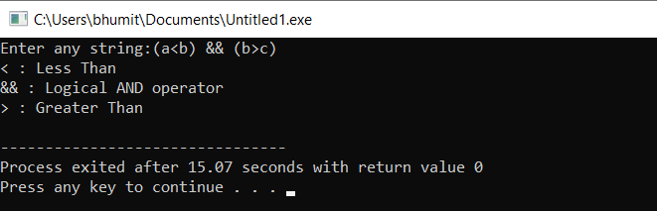

**TEST CASE -3:** 